Gradable Antonyms

🔹 What is Gradable Antonyms
# Source: AI Source: Provided by: [Data Path: Persons Table -> ID Column: 1, Name_En Column: Motasem Essam] -> From: [Chatgpt (GPT-4-turbo)] on [7/30/2025]
Gradable antonyms are word pairs that express opposite meanings on a continuous scale. These words are not absolute opposites, and often allow for degrees or gradations between them.

🧠 Definition:
# Source: AI Source: Provided by: [Data Path: Persons Table -> ID Column: 1, Name_En Column: Motasem Essam] -> From: [Chatgpt (GPT-4-turbo)] on [7/30/2025]
Gradable antonyms describe opposite ends of a spectrum, where intermediate levels exist between the two extremes.

📌 Key Characteristics:
# Source: AI Source: Provided by: [Data Path: Persons Table -> ID Column: 1, Name_En Column: Motasem Essam] -> From: [Chatgpt (GPT-4-turbo)] on [7/30/2025]
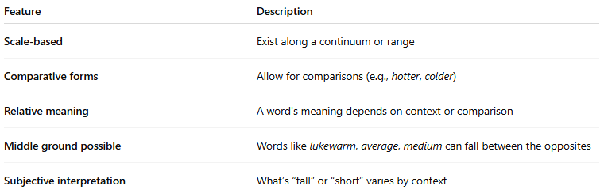
Feature | Description
Scale-based | Exist along a continuum or range
Comparative forms | Allow for comparisons (e.g., hotter, colder)
Relative meaning | A word's meaning depends on context or comparison
Middle ground possible | Words like lukewarm, average, medium can fall between the opposites
Subjective interpretation | What’s “tall” or “short” varies by context

📚 Examples of Gradable Antonym Pairs:
# Source: AI Source: Provided by: [Data Path: Persons Table -> ID Column: 1, Name_En Column: Motasem Essam] -> From: [Chatgpt (GPT-4-turbo)] on [7/30/2025]
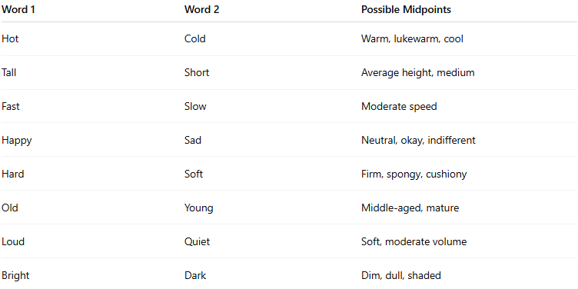
Word 1 | Word 2 | Possible Midpoints
Hot | Cold | Warm, lukewarm, cool
Tall | Short | Average height, medium
Fast | Slow | Moderate speed
Happy | Sad | Neutral, okay, indifferent
Hard | Soft | Firm, spongy, cushiony
Old | Young | Middle-aged, mature
Loud | Quiet | Soft, moderate volume
Bright | Dark | Dim, dull, shaded

✏️ In Context:
# Source: AI Source: Provided by: [Data Path: Persons Table -> ID Column: 1, Name_En Column: Motasem Essam] -> From: [Chatgpt (GPT-4-turbo)] on [7/30/2025]
- This room is not hot, but it’s not cold either — it’s somewhere in between.
- She isn't very tall, just a little taller than average.

🔁 Comparison:
# Source: AI Source: Provided by: [Data Path: Persons Table -> ID Column: 1, Name_En Column: Motasem Essam] -> From: [Chatgpt (GPT-4-turbo)] on [7/30/2025]
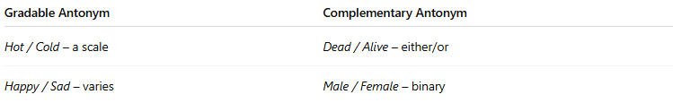
Gradable Antonym | Complementary Antonym
Hot / Cold – a scale | Dead / Alive – either/or
Happy / Sad – varies | Male / Female – binary

